# Task – Written Communication

Using MS Word, write two paragraphs on why you want this position and why we should choose you. Save the file on the desktop as your full name

# Task – Manual Arithmetic

Perform this task with the pen and paper provided. Without the use of a calculator, add 57.3 and 2.7, and then multiply the sum by 56.

# Task – Sales Admin

Use Excel on the computer provided, and save the file on the desktop as your full name.

A client wishes to purchase one primary license ($4000 each) and two additional license ($2000 each). Shipping is $120, and is not discountable. Due to the large order we will give a 5% discount for the licenses. Our client is within Singapore and local taxes apply. Create a quotation in excel listing as a minimum, the items, an undiscounted subtotal, discounted subtotal, applicable tax, and grand total the client is to pay.

# Lateral Thinking

Estimate the cost of washing the windows of all buildings in the central business district of a city which is 2 km x 3 km in area and is all high rise buildings. List your assumptions and show your working.

# IQ

If two typists can type two pages in two minutes, how many typists will it take to type 18 pages in six minutes?

A: 3 B: 4 C: 6 D: 12 E: 36

# IQ

One of the following sentences given below means approximately the same as the proverb: "Don't count your chickens until they are hatched." Choose the one:

1. Some eggs have double yolks, so you can’t really count eggs and chickens.
2. You can’t walk around the henhouse to count the eggs because it will disturb the hens and they won’t lay eggs.
3. It is not really sensible to rely on something that has not yet happened and may not ever happen.
4. Since eggs break so easily, you may not be accurate in your count of future chickens.

# IQ

Which word of four letters can be added to the front of the following words to create other English words?

CARD BOX CODE BAG HASTE

# IQ

Which of the designs best completes the following sequence?

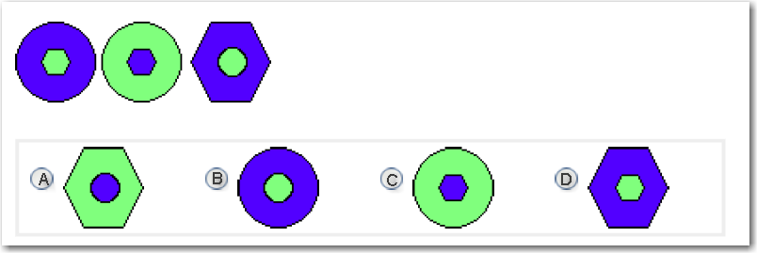

# Contract

Read Datgel’s EULA sections 1, 7.1, 7.2, 7.3 and 7.7.

1. What are the fundamental differences between a Single User hardware key license and an Office Wide License?
2. Can a client use a Single user hardware key license outside their office?

# Advanced Excel, see file “Excel test ####-##-##.xlsx”